**AFRICA INDUSTRIAL INTERNET PROGRAMME**

AIIP Action learning deign thinking project report

Seloke Fabiao

Sfabiao18@aiip.alueducation.com

# Introduction

Crime is a major problem in most major cities around the world more especially in Johannesburg’s Central business district. In the past few years more and more companies are relocating their office headquarters away from the CBD. For companies that stayed in the Johannesburg CBD, the daily commute to work is increasingly becoming a very unsafe for employees of those companies. Finding a solution or a method to improve safety during travels from and to work makes for an ideal I&I (Innovation & Intrapreneurship) action-learning project. This project is selected because the solution is not obvious and the design thinking process can be applied for better understand needs/issues, to identify and develop effective solutions.

# Process followed

The overall crime problem in the Johannesburg CBD is a massive problem that will take far more resources and time to resolve, as a first step for this project, it was imperative to use design think approach to first understand and to scope the problem correctly such that is can be in the form of a scalable solution that can be implemented to the whole of the city.

## Design thinking overview

## Design Thinking is a method designers use in ideation and development. The method describes a human-centred, iterative design process consisting of 5 steps—Empathize, Define, Ideate, Prototype and Test. Design thinking is useful in tackling problems that are ill-defined or unknown.

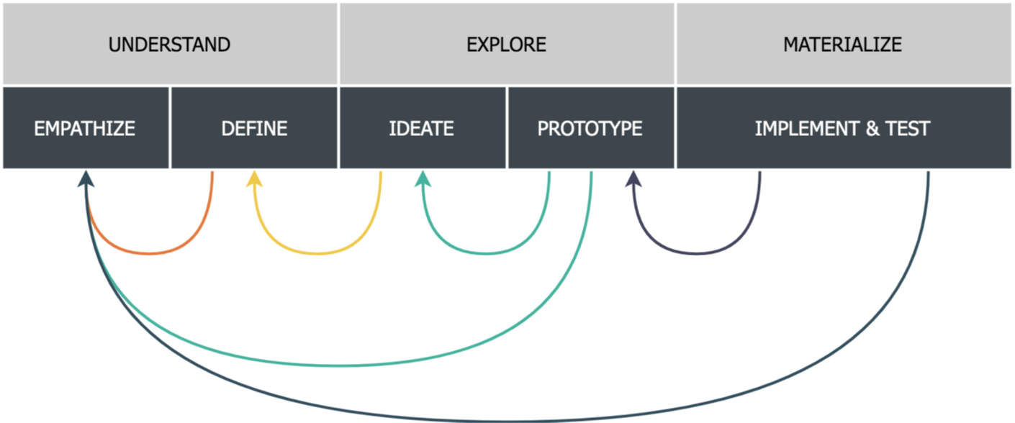

According to <https://www.interaction-design.org/literature/topics/design-thinking> the five stages of design thinking are described as follows:

*“Empathize*

*The first stage of the Design Thinking process demands gaining an empathic understanding of the problem you’re trying to solve, mainly through some form of user research. Empathy is crucial because it allows you to set aside your own assumptions about the world in order to gain insight into users and their needs.*

*Define*

*During the Define stage of Design Thinking, you put together the information you have created and gathered during the Empathize stage. You analyse your observations and synthesize them in order to define the core problems you and your team have identified so far. This is where you ensure that what you are addressing sits in sharp relief before you, its properties known in full.*

*Ideate*

*The process’s third stage finds you ready to start generating ideas. With the knowledge you have gathered in the first two phases, you can start to “think outside the box” to identify new solutions to the problem statement you’ve created, and you can start to look for alternative ways of viewing the problem.*

*Prototype*

*In the Prototype phase of Design Thinking, your design team produce a number of inexpensive, scaled-down versions of the product or specific features found within the product so you can investigate the problem solutions generated in the previous stage.*

*Test*

*In the Test phase of Design Thinking, you rigorously test the completed product using the best solutions identified during the prototyping phase. This is the final stage; however, in an iterative process, the results generated during the testing phase are what you will often use to redefine one or more problems.”*

## Design thinking application

Given the limited time and resources available for this project we decided to limit all the solution to one building in Johannesburg CBD. This is our regular work environment at 138 Eloff Street Johannesburg (building Name is the same as the street address). To gain better insights into crime trends and patterns we decided to perform an analysis of the vicinity of the work area and to review previous crime incidents around the area.

### 138 Eloff Street (GPS Location: -26.194743, 28.042736) – Empathise First iteration (Research)

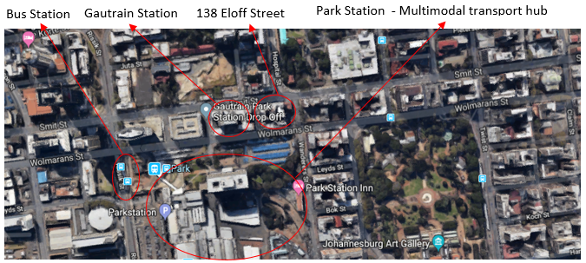

138 Eloff Street is at the edge of the Braamfontein improvement district. It is near Johannesburg transport main transport hub. The 138 Eloff street building is positioned close to Johannesburg’s main multimodal transport hub. This provides transport options such as Train (Metro and Grautrain), Bus, Taxi. The approximately 200 employees based at 138 Eloff Street have a variety transport options to use to commute to work. The estimated modes of transport statics are as following 10% Metrorail, 20% Gautrain, 40% Private Motor Vehicle and 30% Walk to work.

A review of the recent reported incidents that occurred around the building was conducted as part of the “Empathise First iteration process”. The red circles in the map below shows where the recent reported incidents occurred. The types of reported incidents include; Armed robbery, muggings, attempted high jacking and pick pocketing.

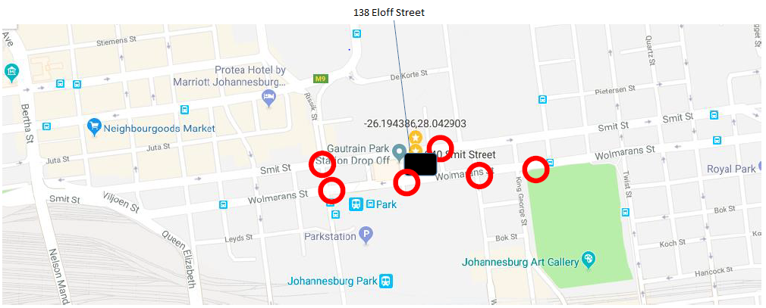

### Understanding the problem – Empathise second iteration (Research)

To obtain a clearer picture of the crime situation at 138 Eloff Street, we decided to interview a few colleagues. The following questions were developed for the interviews:

1. How long have you worked at 138 Eloff Street?
2. Do you feel safe at or coming to 138 Eloff Street?
3. Do you feel that there is a security or safety problem at 138 Eloff street?
4. How severe do you feel that the problem is on a scale of 1 to 10?
5. Have you been a victim of any criminal activity in or around your workplace?
6. Please elaborate on any experience.
7. Have you ever felt that your life has been in danger in or around 138 Eloff Street?
8. Have you ever felt that your possessions has been in danger in or around 138 Eloff Street?
9. Do you think the crime incidents around 138 Eloff Street are organised or random/opportunistic crimes?
10. Do you feel that the current steps being taken will sufficiently address the risks?
11. Do you have any ideas or proposed solutions to safety risks at 38 Eloff Street?
12. Do you think Transnet as your employer should be responsible your safety in the vicinity of your work place?
13. Do you think monitoring the area will reduce crime?
14. What steps have you taken to ensure your personal safety?
15. If the crime situation doesn't improve will you reconsider your employment with Transnet

A team discussion was held and the initial list it was decided that the questions to be trimmed to 10 concise questions:

1. How long have you worked at 138 Eloff Street?
2. Do you feel safe at or coming to 138 Eloff Street?
3. Do you feel that there is a security or safety problem at 138 Eloff street?
4. Have you been a victim of any criminal activity in or around your workplace, and please elaborate on any experience.
5. Do you think the crime incidents around 138 Eloff Street are organised or random/opportunistic crimes?
6. Do you feel that the current steps being taken will sufficiently address the risks?
7. Do you have any ideas or proposed solutions to safety risks at 38 Eloff Street?
8. Do you think Transnet as your employer should be responsible your safety in the vicinity of your work place?
9. Do you think monitoring the area will reduce crime?
10. What steps have you taken to ensure your personal safety?

Interviews were conducted on 11 colleagues and the results were collated below:

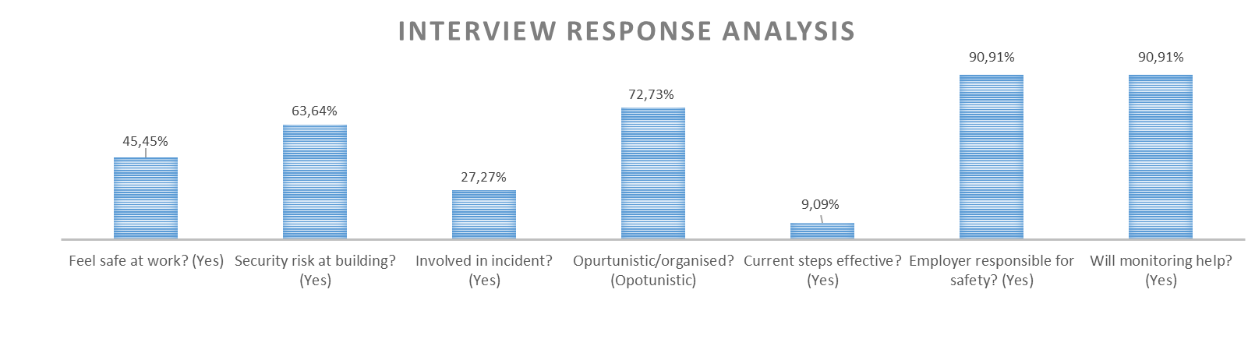

It is clear from the people interview that there is a general feeling of a lack of safety when traveling to the work place while the was a marginal agreement that the security with the building was sufficient. There was also an over whelming feeling that increased monitoring will assist in mitigation of the crime problem in the area.

### Defining the Problem

The interview phase provided clearer insights that help develop a definition a project scope definition that was achievable and implementable. The formal project definition was defined as:

*“Employees have experienced an increase in robberies in the vicinity of the 138 Eloff Street Office. This problem requires research to evaluate the extent of the problem as well as to gauge employee safety concerns. A cost effective solution to improve security as well as employee and public safety within the immediate vicinity of the 138 Eloff Street Offices is required”*

The definition above moved the initial project focus (see the initial project definition below) from a security threat within the building to a security threat in the vicinity of the building. This was as result of the empathise phase which the users (our colleagues) overwhelmingly agreed that there was no major problem within the building.

*“Project Description: Transnet Freight Rail, Technology Management have had security breaches in the recent past which is effecting employee safety and mental wellbeing. A solution to address this security concern is of great importance.”*

### Finding a solution – Ideate phase first iteration

A brainstorming session of free flowing ideas was held with all members of the ground contributing ideas on to the groups slack channel. The main idea of this phase was to use the learnings from the interview phase to craft ideas around how to make the commute to work safer. The proposed ideas can be loosely grouped into the following categories:

1. Increased policing
2. Visible policing - Participants felt increased monitoring/security would deter crime.
3. Armed Security - Participants felt increased monitoring/security would deter crime.
4. Forming a security task team with government, and businesses in the area.
5. Deploy military.
6. Mobile police stations.
7. Personal safety improvement
8. Changing commuting patterns/hours – This is because of crime occurred during slow moving peak traffic hours
9. Carry Weapons – Self-defence was raised as a common theme on how to make pedestrians feel safer
10. Shuttle Service – Motorist felt parking in other location and using company provided shuttle service would improve safety.
11. Provide pedestrians with pepper spray.
12. Audio monitoring for signs of distress.
13. Audible Warnings.
14. Crime Whistles.
15. Training and awareness.
16. Bullet proof vehicles.
17. Personal panic buttons.
18. App to report incidents.
19. Vehicle following drone. (Supervised passage)
20. Increased monitoring
21. CCTV monitoring – Participants felt increased monitoring/security would deter crime.
22. AI monitoring - Participants felt increased monitoring/security would deter crime.
23. Drones monitoring - Participants felt increased monitoring/security would deter crime
24. Armed Drones - Participants felt increased monitoring/security would deter crime.
25. App to monitor audio from smartphone for distress.
26. Relocation
27. Work from home – Avoiding the travel to work was a popular proposal amongst those interviewed.
28. Moving Offices.
29. Build a company campus.
30. City intervention
31. More street lighting.
32. Renovation of the immediate vicinity.
33. Reduce hiding spaces. (empty buildings)
34. Anti-crime advertising.
35. Reduce unemployment rate.
36. Larger sidewalks.
37. Remove public benches.
38. Improve public transport.
39. Community upliftment programs.
40. Gautrain expansion.

### Fine turning the ideas– Ideate phase second iteration

* + - 1. An APP for reporting crime incidents – there is a general crime reporting apathy amongst those interviewed. This was due to the perception that very little is done about crime, however there is a double edged sword for incident under reporting. Under reporting of crime results in less police resources being allocated to fight that crime. This necessitates the creation of an easier system/method to report crime that is both real time and widely available. A mobile application is a clear and simple answer to that problem. It was therefore decided that an application will be designed for this purpose.
      2. Drone monitoring -
      3. AI monitoring – Since police can not

Clear Understanding of  Design Thinking and the value it offers.

Showed concrete evidence of Design Thinking tools and approaches in practice.

Completed the summative assessment by applying Design Thinking in a real world setting. This resulted in clear learnings through the peer and manager / colleague meetings.

Reflections indicate the student will pursue the Design Thinking methodology in the future

|  |
| --- |
| **I&I Summative Assessment Rubric** |

Below is the rubric for the I&I summative. Your report will be evaluated according to the criteria outlined in the rubric covering all the facets of the I&I module: Innovation and Entrepreneurship, Changemaking and Entrepreneurial Leadership, and, Systems Thinking and Leading Change in Systems.

|  |  |  |  |  |
| --- | --- | --- | --- | --- |
|  | Did not submit  (DNS) or Does not meet expectations - DNME- | Minimally meets expectations - MME | Adequately meets expectations - AME | Fully meets or exceeds expectations - FMOEE |
|  | 0 | 1 | 2 | 3 |
| **Understand and Apply Innovation and Entrepreneurship Principles** | The report did not address this learning | Lacks clear demonstration of the application of Design Thinking.  Doesn’t provide an indication of outcomes and learning | Clear Understanding of  Design Thinking and the value it offers.  Showed concrete evidence of Design Thinking tools and approaches in practice  Completed the summative assessment by applying Design Thinking in a real world setting. | Clear Understanding of  Design Thinking and the value it offers.  Showed concrete evidence of Design Thinking tools and approaches in practice.  Completed the summative assessment by applying Design Thinking in a real world setting. This resulted in clear learnings through the peer and manager / colleague meetings.  Reflections indicate the student will pursue the Design Thinking methodology in the future |
| **Understand Principles of Changemaking/Entrepreneurial Leadership** | The report did not cover this learning | Showed general understanding of the value of changemaking but did not demonstrate learning and growth in this regard. Was able to assess self against entrepreneurial leadership framework. | Showed clear understanding of the value of changemaking.  Was able to assess self against entrepreneurial leadership framework.  Used the framework for learning agility. | Showed clear understanding of the value of changemaking.  Was able to assess self against entrepreneurial leadership framework, and provide clear learnings and key takeaways.  Used a framework for learning agility and demonstrated effort towards building capability. |
| **Understand Principles of System Thinking and Leading Change in Systems** | The report did not cover this learning | Evidence that the student has an general understanding of  systems and key ideas of how to think about systems. | Clear evidence that the student has an understanding of  systems and key ideas of how to think about systems.  Ability to show what role  leadership plays in  systems in their project. | Clear evidence that the student had a sound understanding of  systems and key ideas of how to think about systems.  Ability to show what role  leadership plays in  systems in their project.  Used methods for driving change in systems. |